
Department of Computer Science
MY University, Islamabad
Department of Computer Science
MY University, Islamabad

Project:
Rental Villa - Car Rental Android App

Submitted By:

Uzair Asif (bcs222009)
Ammar Yasir (bcs222006)
Ibrahim Zafar (bcs222016)

Course:
Mobile Application Development

Project Advisor:

Dr Rana Mudassar Rasool

Semester: 6th
Date: 7th July,2025
Rental Villa - Car Rental Android App

1. Project Overview
Rental Villa is an Android-based car rental application developed in Java using SQLite for local data storage.
The application allows users to register, log in, view and book available cars, check booking history, and submit feedback.
It also includes an administrative panel for the owner to manage cars and view bookings and feedbacks. The application features a splash screen with a logo, a clean dashboard interface, and detailed car selection and booking functionality.

2. Objectives
-Provide a simple and effective platform for users to rent cars.
- Ensure car availability checking based on selected rental dates.
- Facilitate secure user and owner authentication.
- Allow submission and viewing of user feedback.
- Maintain booking history and payment status records.

3. Project Scope
This application is intended for small to medium-scale car rental businesses. It focuses on:
- Booking cars with start and end dates.
- Preventing booking conflicts.
- Managing user and car data locally.
- Handling basic feedback and payment status operations.

4. System Requirements
- Android Studio (Electric Eel or later)
- Android SDK with Java support
- SQLite database (built-in with Android)
- Physical or Virtual Android device for testing

5. Functional Requirements
- User Registration and Login
- Owner Registration and Login (Single Admin Model)
- Car Management (View cars)
- Car Booking with Date Range Conflict Check
- Display Car Details (Name, Number, Price, Description)
- User Booking History
- Feedback Submission and Review
- Splash Screen with Logo

6. Database Design

The application uses SQLite with the following tables:
- Users(ID, Name, Email, Password, Phone)
- Owner(ID, Username, Password)
- Cars(ID, CarName, CarNumber, PricePerDay, Details)
- Bookings(ID, UserID, CarID, StartDate, EndDate, PaymentStatus)
- Feedback(ID, UserID, Message)

7. Key Application Screens
- Splash Screen: Displays app logo and name.
- Home Screen: Navigate to Owner/User Login or Register.
- User Dashboard: Book Car, Submit Feedback, Logout.
- Owner Dashboard: View Bookings, View Feedback, View Users.
- Car Selection: Lists available cars.
- Booking Confirmation: Displays user, car, dates, and total amount.

8. Future Enhancements
- Online payment integration (e.g., Stripe or PayPal)
- Admin car addition/removal.
- Push notifications for booking reminders.
- Improved UI with animations and image support for cars.
- Google Maps for car pickup locations.

JAVA Codes:
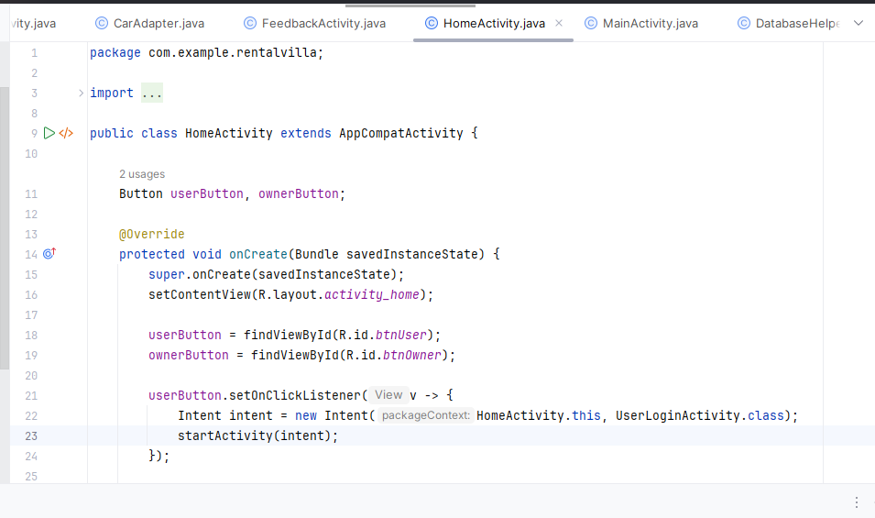
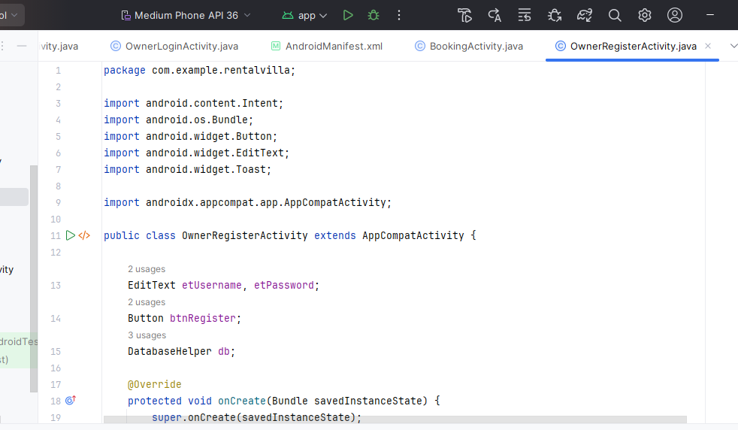

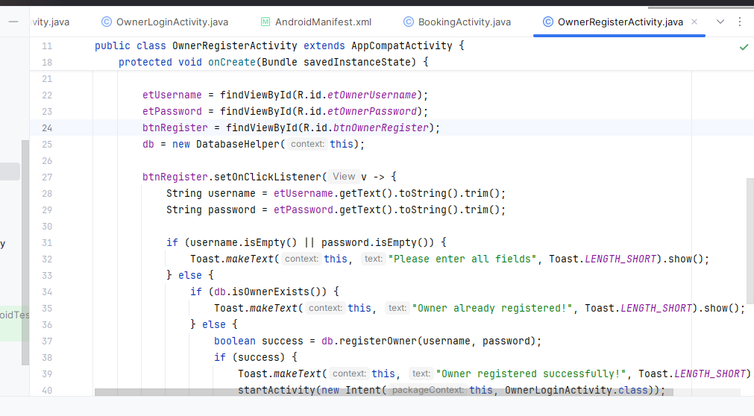

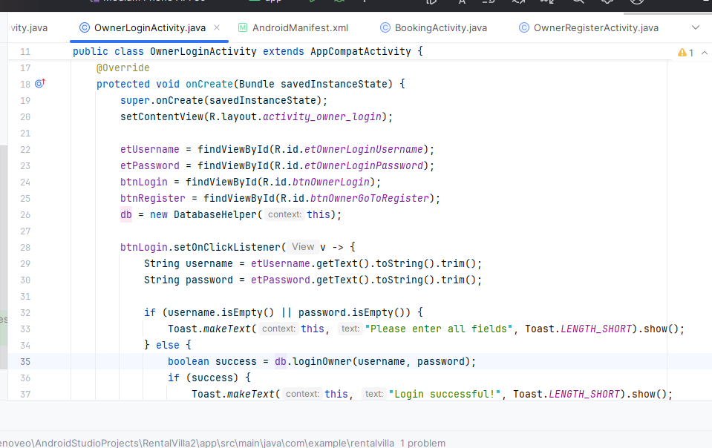

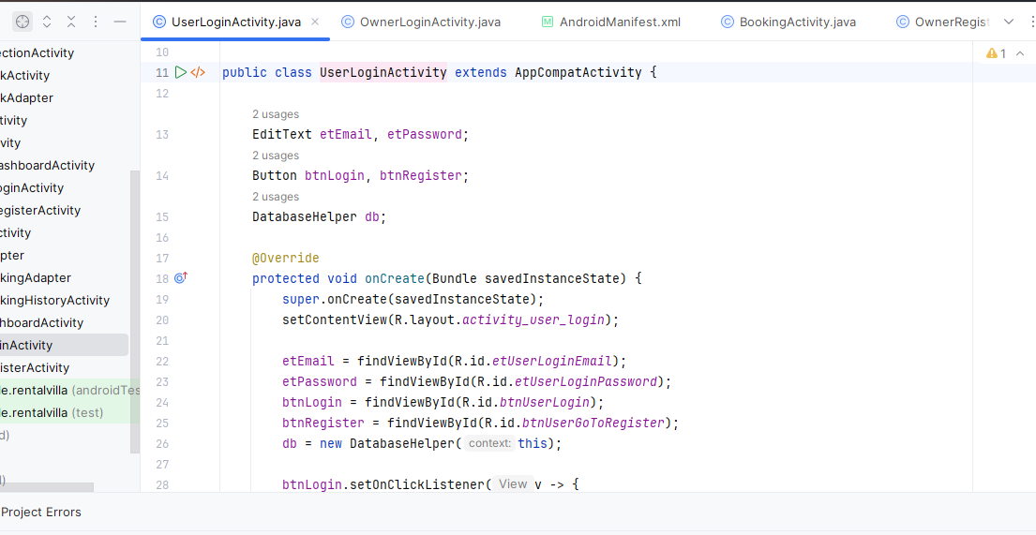
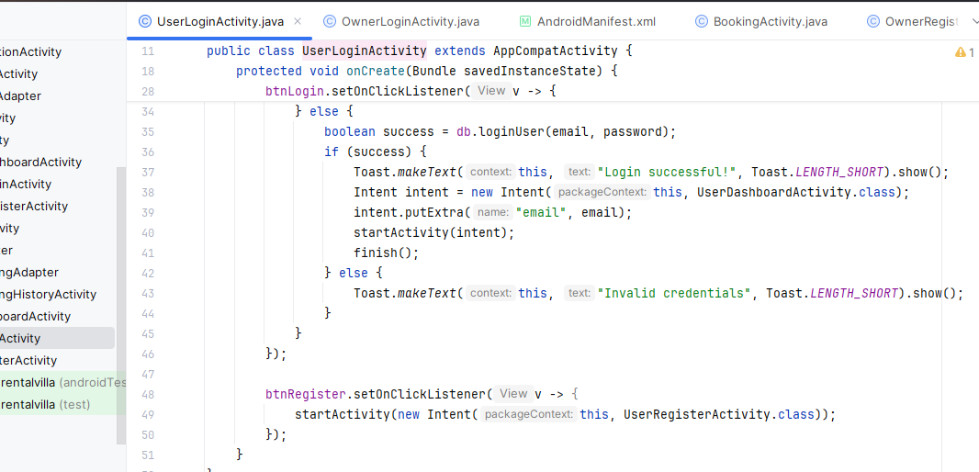

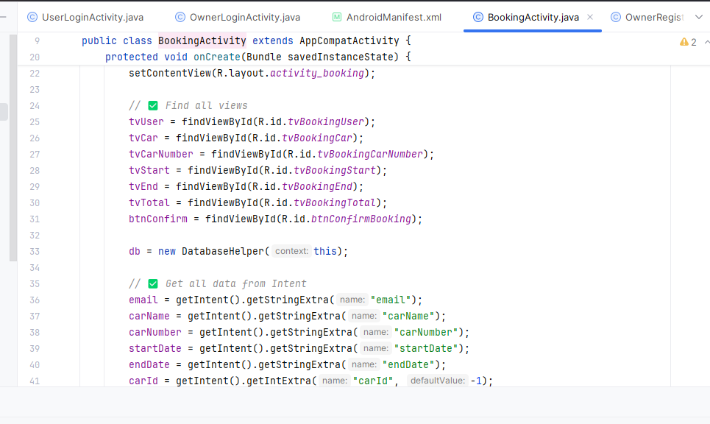

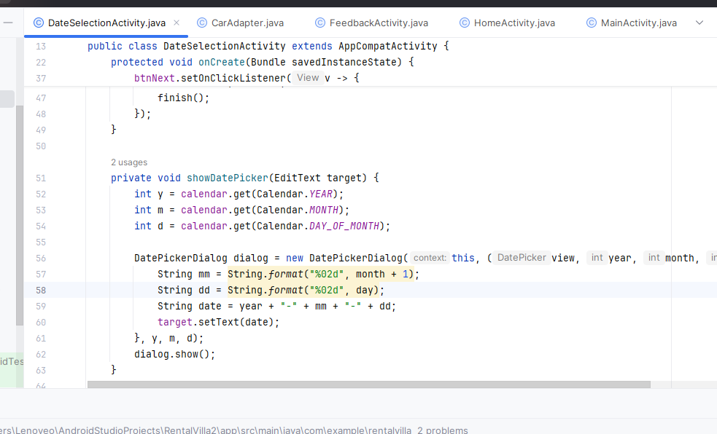

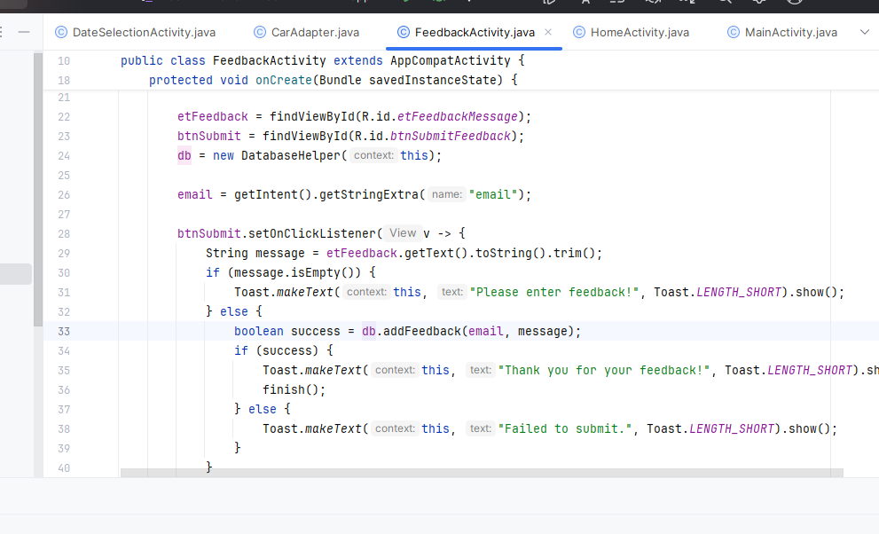

XML Codes:
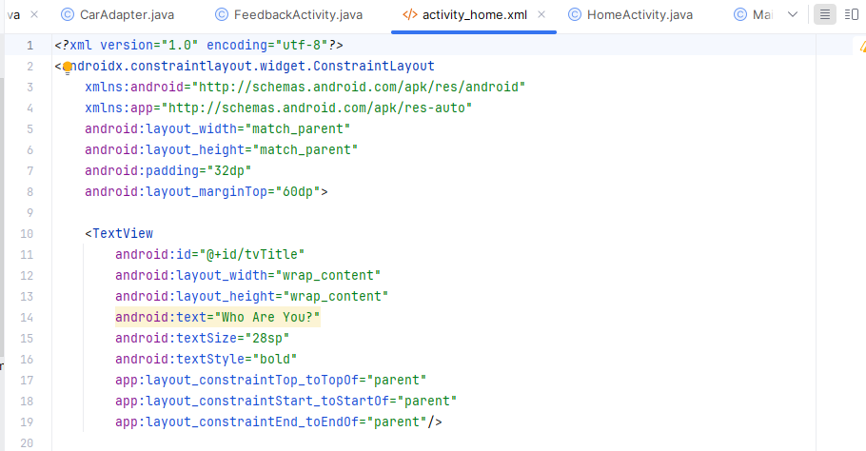
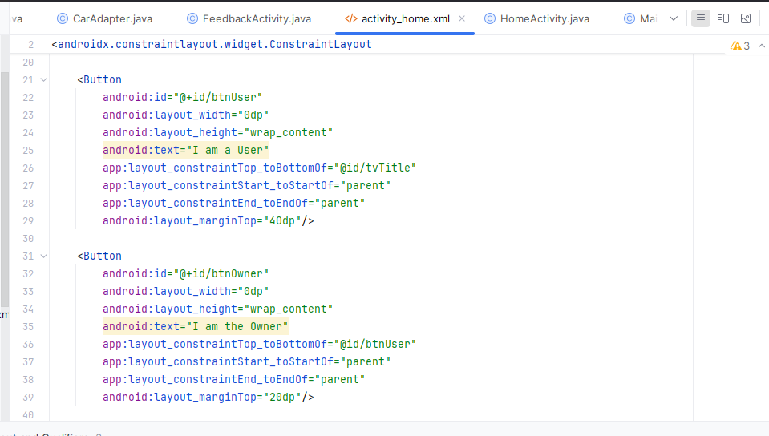

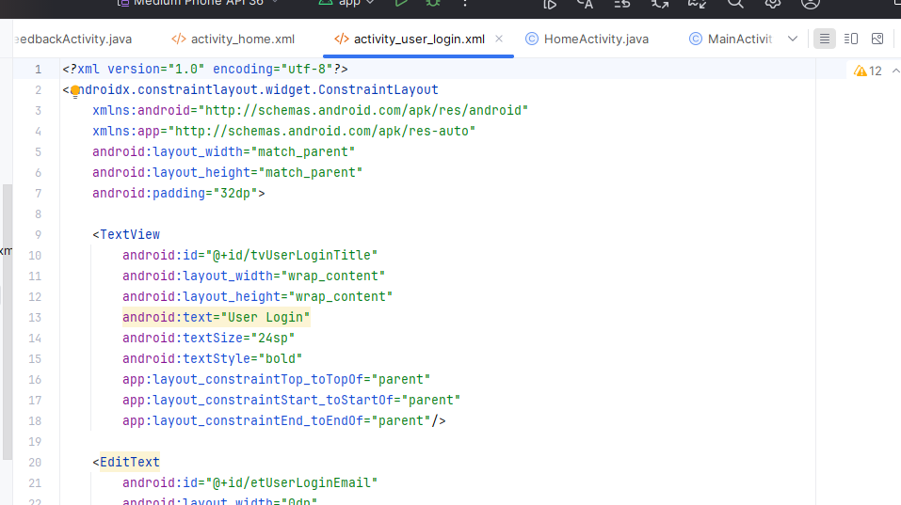

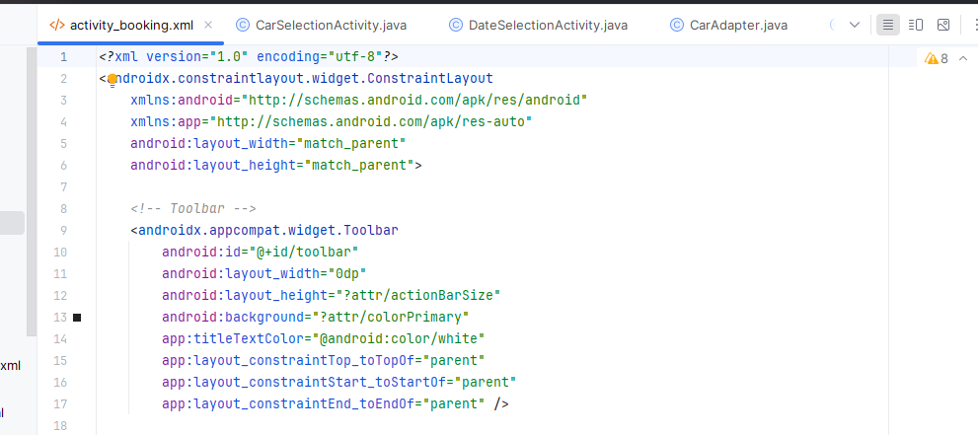

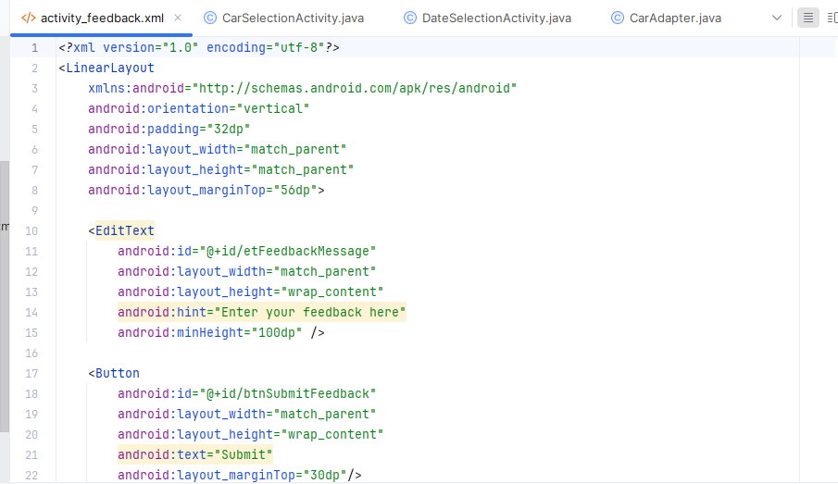


Screenshots of Application:
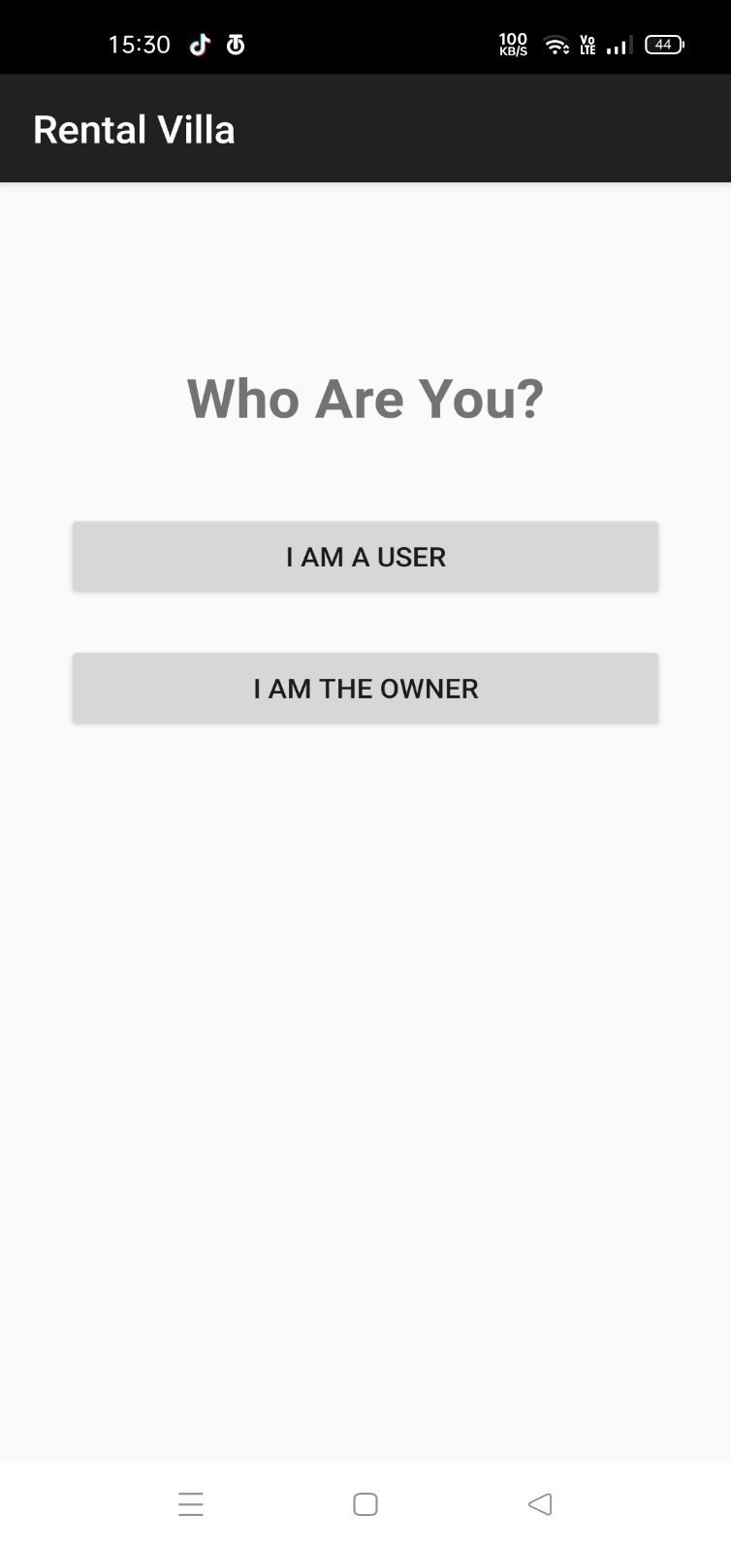

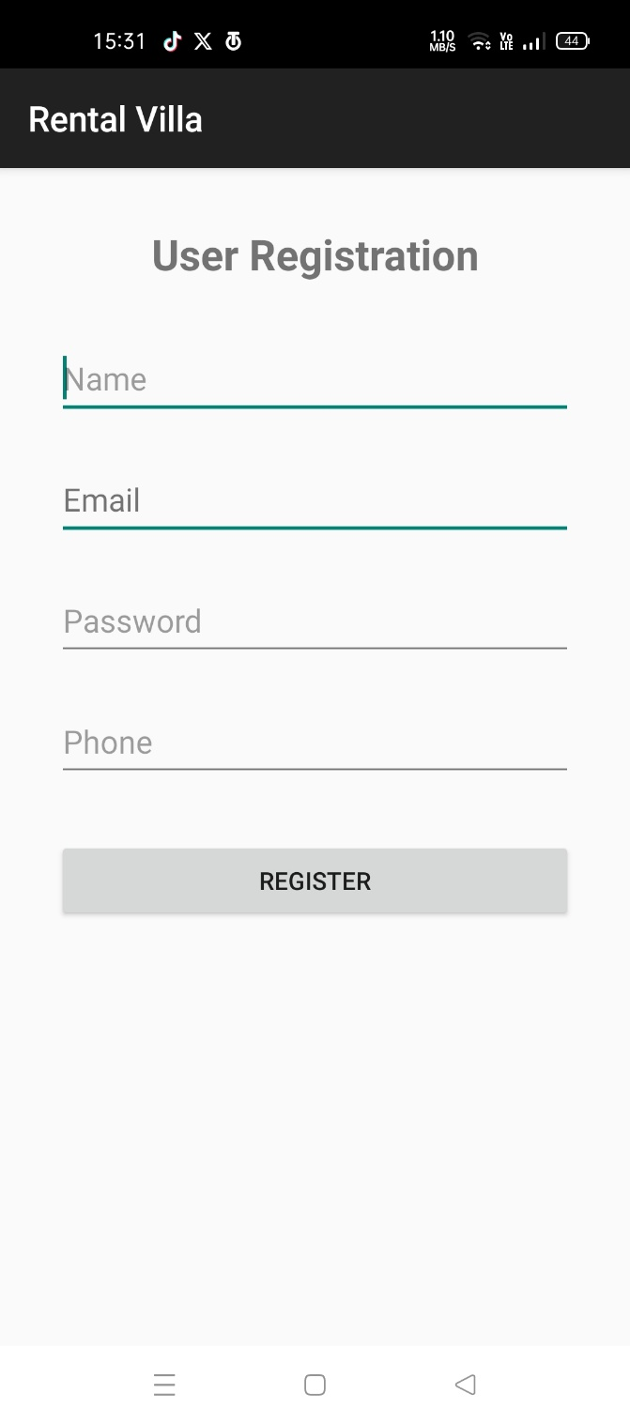
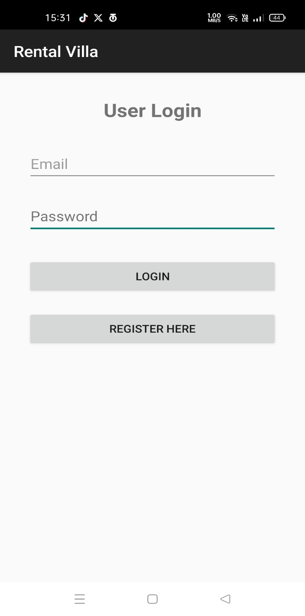

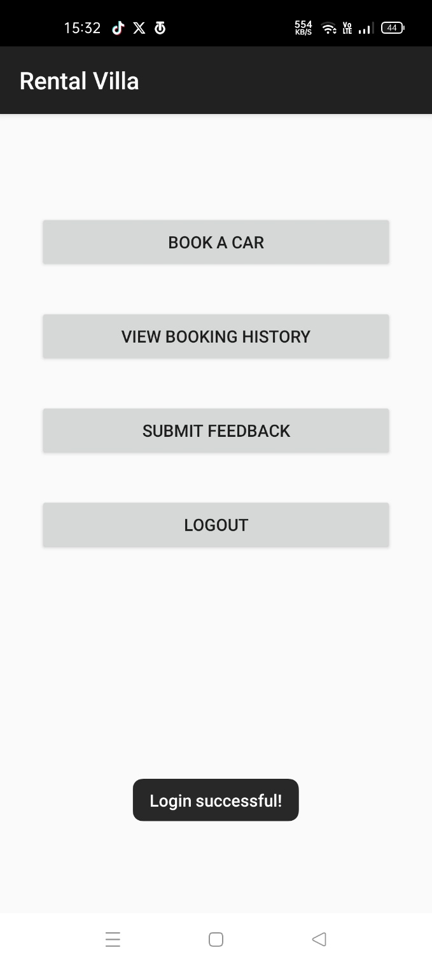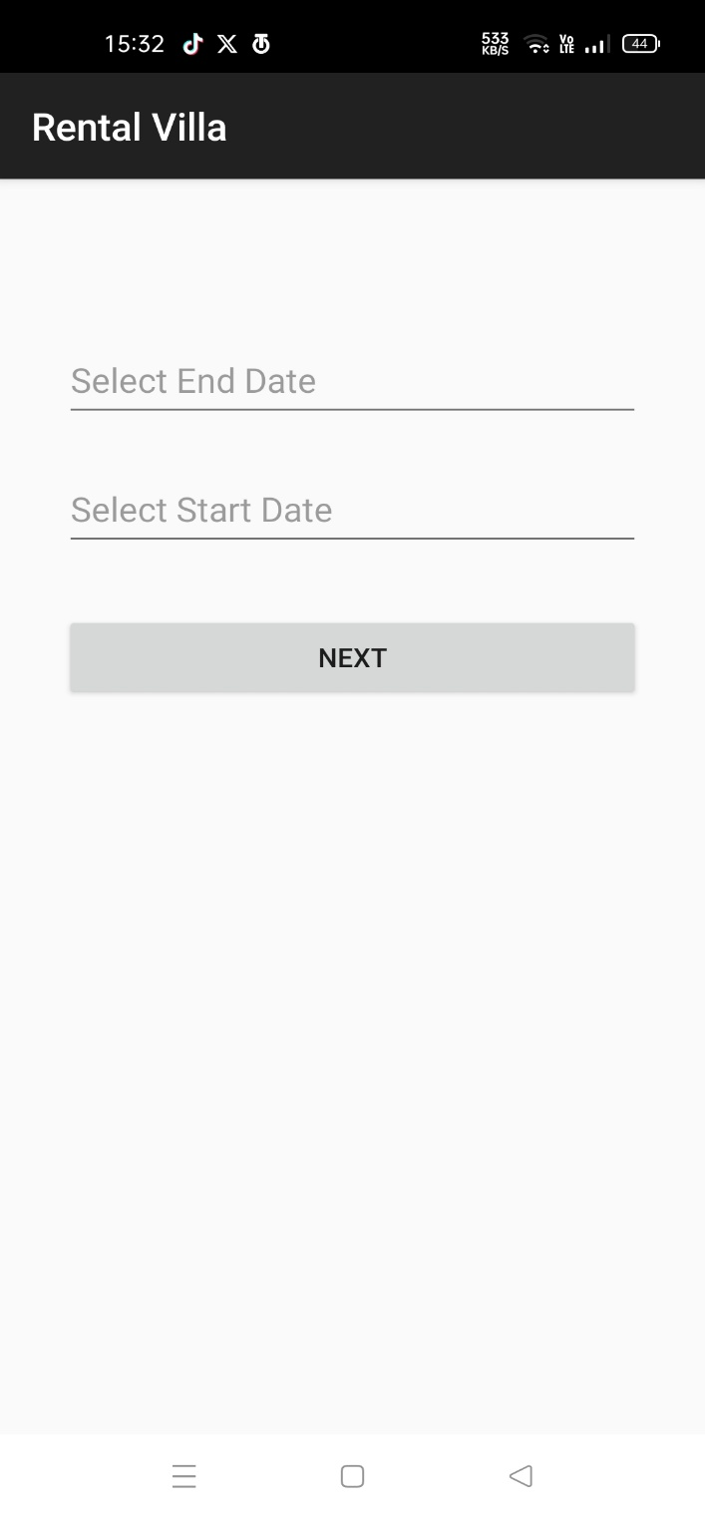

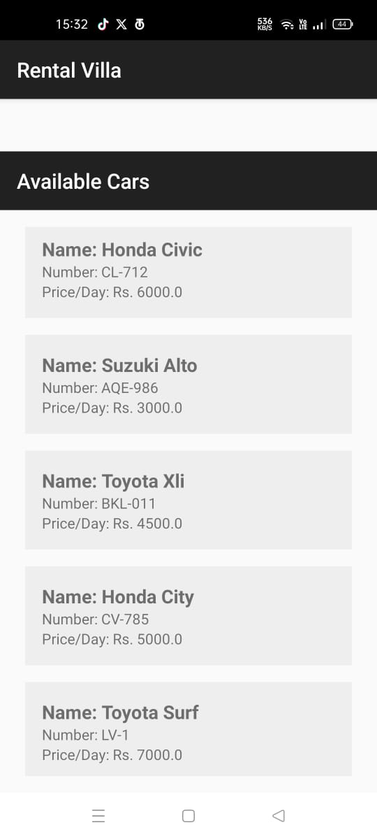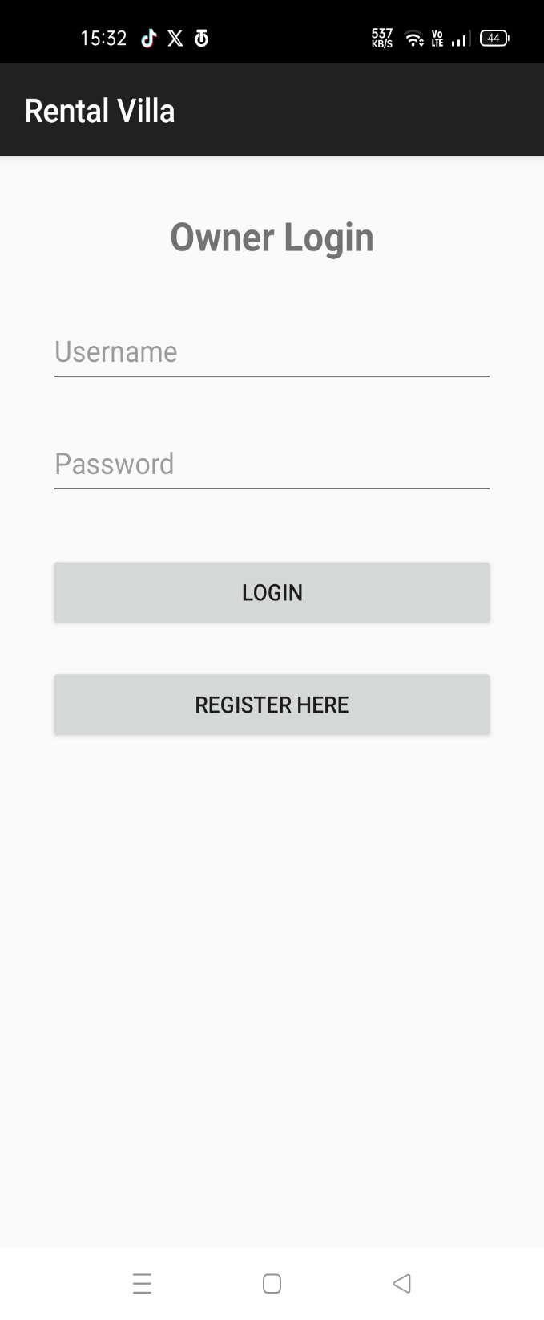

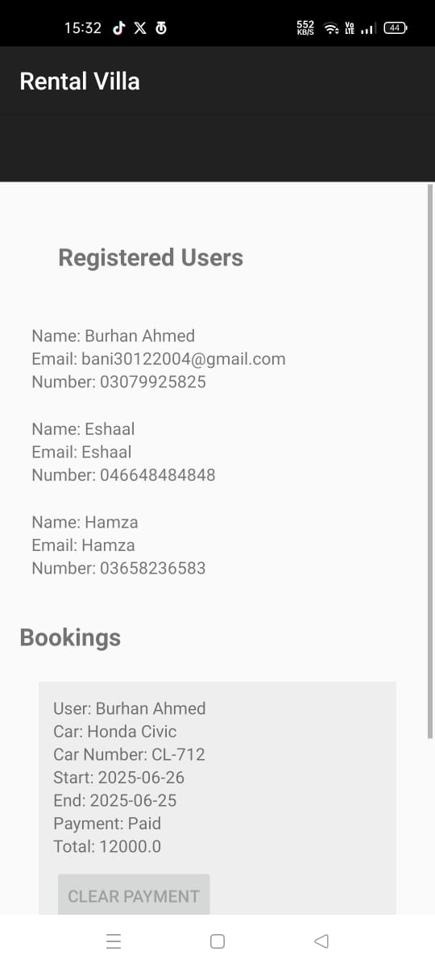

END

